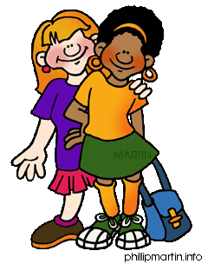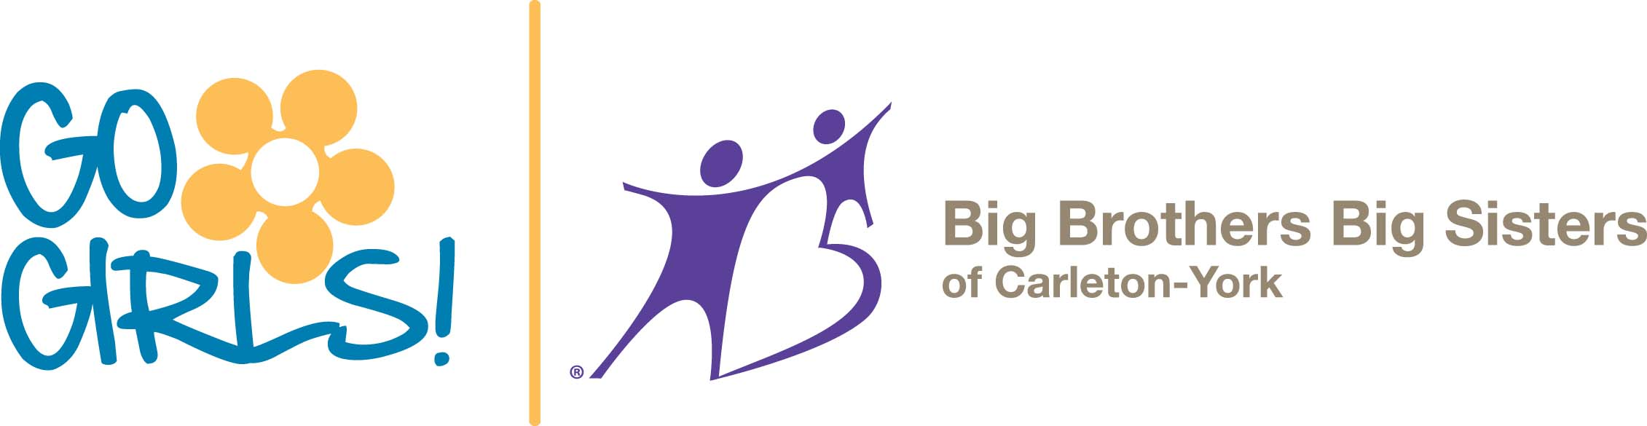

ARE YOU A MIDDLE SCHOOL GIRL?

ARE YOU LOOKING FOR FUN ACTIVITIES THIS SUMMER?

THEN JOIN US!

Big Brothers Big Sisters presents:

GO GIRLS! HEALTHY BODIES HEALTHY MINDS!

Participate in fun, educational games and activities that encourage mentor/participant relationship-building as well as self-reflection and group discussions about what is important to you.

WHEN: July 11th- 13th from 9-3

ACTIVITIES: Swimming, River Tubing, Bowling and Morning Feel Good Sessions

AND IT’S FREE!

Sign up quick! Only 6 spots available

Call 328-2094 to join

\*Transportation and Food will be provided